* 1. General Information

|  |  |  |  |  |
| --- | --- | --- | --- | --- |
| **Design Code** | **Unit System** |  |  |  |
| IS456:2000 | N, mm | 25.00MPa | 415MPa | 415MPa |

* 1. Section & Factor

|  |  |  |  |  |
| --- | --- | --- | --- | --- |
| **Section** |  |  |  |  |
| 500x500mm | 1.000 | 3.500m | 1.000 | 3.500m |

* + - * Frame Type : Braced Frame
  1. Force

|  |  |  |  |  |  |  |
| --- | --- | --- | --- | --- | --- | --- |
|  |  |  |  |  |  |  |
| 100.00kN | 50.00kN·m | 70.00kN·m | 40.00kN | - | 100.00kN | 100.00kN |

* 1. Rebar

|  |  |  |  |  |  |
| --- | --- | --- | --- | --- | --- |
| **Main Bar-1** | **Main Bar-2** | **Main Bar-3** | **Main Bar-4** | **Hoop(End)** | **Hoop(Mid)** |
| 8-3- P8 | - | - | - | P5@50.00 | P 5@100 |

* 1. Tie Bar

|  |  |  |
| --- | --- | --- |
| **Apply Tie Bar to Shear Check** | **Tie Bar** |  |
| Yes | #3 | 415MPa |



* 1. Option : Seismic Provisions IS13920:2016
  2. Moment Capacity

|  |  |  |  |
| --- | --- | --- | --- |
| **Check Items** | **Direction X** | **Direction Y** | **Remark** |
| ρ | 0.01631 | 0.01631 | 4,077mm² |
|  | 3.000 | 3.000 |  |
|  | 50.00 | 70.00 |  |
| x (mm) | 366 | 366 |  |
|  | 2,082 | 2,082 |  |
|  | 152 | 254 |  |
|  | 88.45 | 88.45 |  |
|  | 97.09 | 138 |  |
|  | 372 | 372 |  |
|  | 187 | 258 |  |
|  | OK(0.269) | OK(0.269) | OK(0.269) |
|  | OK(0.267) | OK(0.271) | OK(0.270) |

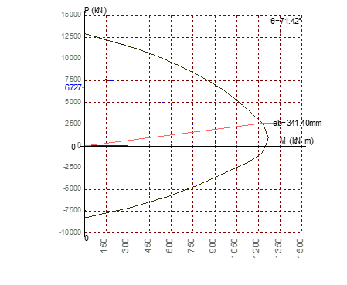

* 1. Shear Capacity

|  |  |  |  |
| --- | --- | --- | --- |
| **Check Items** | **Direction X** | **Direction Y** | **Remark** |
| s (mm) | 50.00 | 50.00 |  |
|  | 141 | 141 |  |
|  | 1,237 | 1,237 |  |
|  | 1,378 | 1,378 |  |
|  | OK(0.207) | OK(0.221) | OK(0.221) |

* 1. Check Dimension by Special Provision for Seismic Design

|  |  |  |
| --- | --- | --- |
|  |  |  |
| 300 | 500 | OK(0.600) |

|  |  |  |
| --- | --- | --- |
|  |  |  |
| 0.45 | 1.000 | OK(0.400) |

* 1. Check Rebar Limit by Special Provision for Seismic Design

|  |  |  |
| --- | --- | --- |
|  |  |  |
| 290 | 600 | OK(0.483) |

|  |  |  |
| --- | --- | --- |
|  |  |  |
| 290 | 600 | OK(0.483) |

* 1. Check Crack Width

|  |  |  |  |
| --- | --- | --- | --- |
| **Check Items** |  | **Wallow(mm)** | **Ratio** |
| Crack Width (mm) | 0.000116 | 2.083 | OK(0.0000483) |